Schema Environment

SELECT * FROM Environment.ServiceType st

SELECT * FROM Environment.ServiceComponentType sct

SELECT * FROM Environment.RegistrationTarget rt

SELECT * FROM Environment.ServiceComponentInstance sci

SELECT * FROM Environment.ServiceGroup sg

SELECT * FROM Environment.ServiceGroupToServiceInstance sgtsi

SELECT * FROM Environment.ServiceInstance si

SELECT * FROM Environment.ServiceInstanceComponentRegistration sicr

SELECT * FROM Environment.ServiceTypeComponentPermission stcp

SELECT * FROM Environment.ServiceTypeComponentRegistration stcr

**ServiceType**

SELECT * FROM Environment.ServiceType st

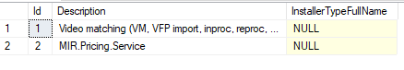

**ServiceComponentType (13 rows)**

SELECT * FROM Environment.ServiceComponentType sct



**RegistrationTarget**

SELECT * FROM Environment.RegistrationTarget rt



**ServiceComponentInstance (145 rows)**

SELECT * FROM Environment.ServiceComponentInstance sci

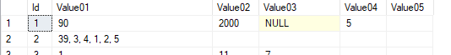

**ServiceGroup**

SELECT * FROM Environment.ServiceGroup sg

Zatim je prazdna



**ServiceGroupToServiceInstance**

SELECT * FROM Environment.ServiceGroupToServiceInstance sgtsi

Zatim je prazdna



**ServiceInstance (13 rows)**

SELECT * FROM Environment.ServiceInstance si



**ServiceInstanceComponentRegistration (139 rows)**

SELECT * FROM Environment.ServiceInstanceComponentRegistration sicr

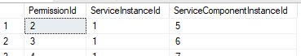

**ServiceTypeComponentPermission (22 rows)**

SELECT * FROM Environment.ServiceTypeComponentPermission stcp



**ServiceTypeComponentRegistration (6 rows)**

SELECT * FROM Environment.ServiceTypeComponentRegistration stc

